3, 4. Resting pulse = 71, Active pulse = 103

5. From model, predicted ActivePulse = 79.0217 + 71 * 0.4793 = 113

7. No, because a resting pulse of 100 BPM is outside the range of our model’s training data (i.e. we would need to perform extrapolation).

Read in the data.

library(readr)

## Warning: package 'readr' was built under R version 4.1.2

data <- read_csv("data.csv")

## Rows: 26 Columns: 5  
## ── Column specification ────────────────────────────────────────────────────────  
## Delimiter: ","  
## chr (2): Initials, Status  
## dbl (3): RestingPulse, ActivePulse, BeatsPerMinute  
##   
## ℹ Use `spec()` to retrieve the full column specification for this data.  
## ℹ Specify the column types or set `show_col_types = FALSE` to quiet this message.

attach(data)  
data

## # A tibble: 26 × 5  
## Initials RestingPulse ActivePulse BeatsPerMinute Status   
## <chr> <dbl> <dbl> <dbl> <chr>   
## 1 KH 65 120 65 RestingPulse  
## 2 AH 73 127 73 RestingPulse  
## 3 IS 71 122 71 RestingPulse  
## 4 MS 78 131 78 RestingPulse  
## 5 MP 73 90 73 RestingPulse  
## 6 AP 73 127 73 RestingPulse  
## 7 EP 76 78 76 RestingPulse  
## 8 WJD 66 97 66 RestingPulse  
## 9 SC 70 134 70 RestingPulse  
## 10 EK 88 125 88 RestingPulse  
## # … with 16 more rows

1. Let x = resting pulse, y = active pulse.

plot(ActivePulse~RestingPulse)  
model = lm(ActivePulse~RestingPulse)  
abline(model)

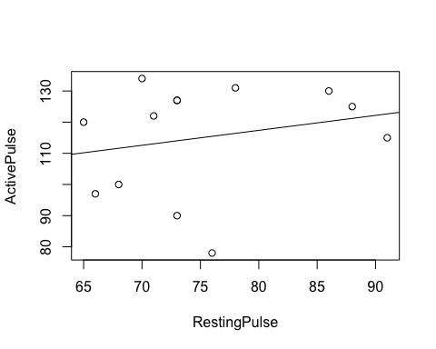 2. Equation: ActivePulse = 79.0217 + RestingPulse * 0.4793

summary(model)

##   
## Call:  
## lm(formula = ActivePulse ~ RestingPulse)  
##   
## Residuals:  
## Min 1Q Median 3Q Max   
## -37.446 -11.611 8.951 12.992 21.430   
##   
## Coefficients:  
## Estimate Std. Error t value Pr(>|t|)  
## (Intercept) 79.0217 47.6282 1.659 0.125  
## RestingPulse 0.4793 0.6295 0.761 0.462  
##   
## Residual standard error: 18.23 on 11 degrees of freedom  
## (13 observations deleted due to missingness)  
## Multiple R-squared: 0.05005, Adjusted R-squared: -0.03631   
## F-statistic: 0.5796 on 1 and 11 DF, p-value: 0.4625

1. Resting pulse: 71
2. Active Pulse: 92
3. From model, predicted ActivePulse = 79.0217 + 71 * 0.4793 = 113
4. Computing the residuals of our data

model$residuals

## 1 2 3 4 5 6 7   
## 9.826298 12.992200 8.950725 14.595889 -24.007800 12.992200 -37.445586   
## 8 9 10 11 12 13   
## -13.652964 21.429987 3.803267 -7.634520 -11.611488 9.761791

hist(model$residuals)

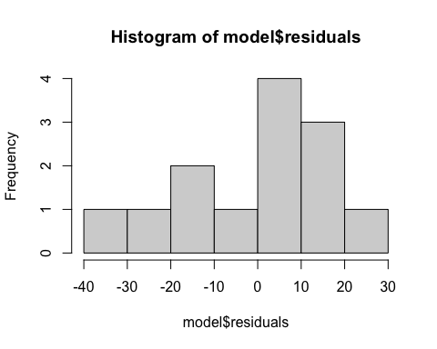

7. No, because a resting pulse of 100 BPM is outside the range of our model’s training data (i.e. we would need to perform extrapolation).